REACT HANDS ON 2

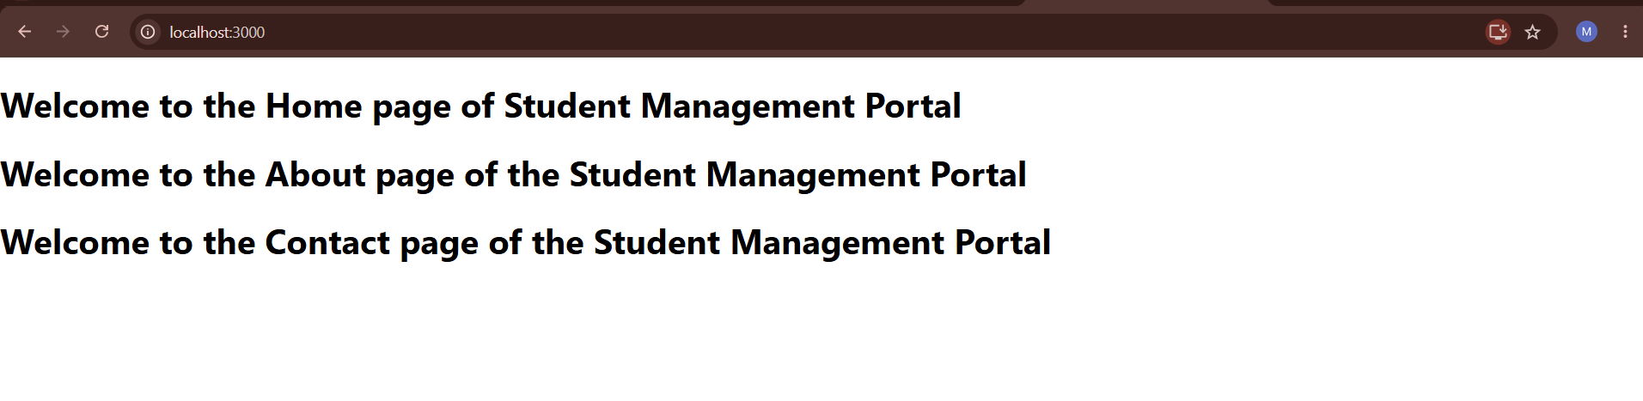

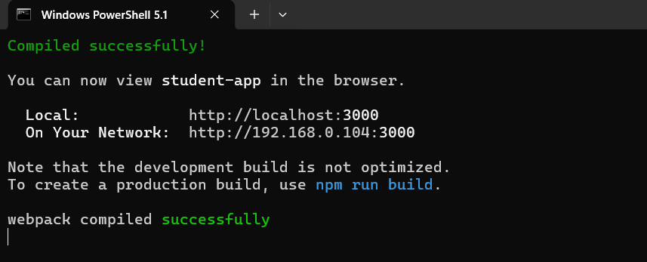

APP.JS

import Home from './Components/Home';
import About from './Components/About';
import Contact from './Components/Contact';

function App() {
return (
<div>
<Home />
<About />
<Contact />
</div>
);
}

export default App;

